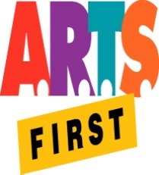 | Hawai‘i State Foundation on Culture & the Arts  Artists in the Schools Program  Partnership Grant Application Form  SY 2019-2020  SIGNATURE FORM

School Name: __________________________________________________________

AITS Contact Statement of Support
I have worked with the Artistic Teaching Partner on this partnership application for an AITS grant.
I approve the final application, including the grant request and school share amounts.
If the partnership receives an AITS grant, I will work with the other teachers and the artist to provide the residency described in the application.
As the AITS Contact, I will be responsible for letting the other teachers know that:
- a one-hour professional development session with the artist is required for the residency teachers
- they need to be present in the classroom at all times during the artist’s sessions
- their support during and in-between sessions is always appreciated by the teaching artist and makes for a more successful residency
- any problems that arise should be brought to the teaching artist’s attention immediately
- their on-line “Individual Teacher Evaluation” is due 30 days after the end of the residency, or by May 31, 2020, whichever is earlier
As l the AITS Contact, I will submit the on-line “School Final Report: Residency Data” form 30 days after the end of the residency, or by May 31, 2020, whichever is earlier.

___________________________________________________________________________
AITS Contact’s Signature Date

AITS Contact Printed Name

Additional Comments:

