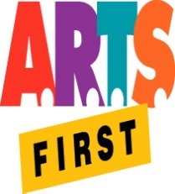 | Hawai‘i State Foundation on Culture & the Arts  Artists in the Schools Program  Partnership Grant Application Form  SY 2019-2020  SIGNATURE FORM | 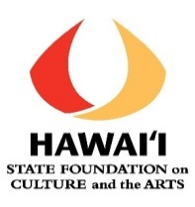

School Name: __________________________________________________________

Artistic Teaching Partner Statement of Support
I have worked with the school on this partnership application for an AITS grant.
I have read through and approve the final application, including the proposed residency costs and grant request.
If the partnership receives an AITS grant, I will work with the school to provide the residency described in the application.
If there are any changes/updates to the grant application, I will contact HSFCA for approval before implementing them.
I will ensure that the residency online final reporting is completed 30 days after the end of the residency or by May 31, 2020, whichever is earliest.

__________________________________________________________________________
ATP’s Signature Date

__________________________________________________________________________
ATP Printed Name

Additional Comments:

