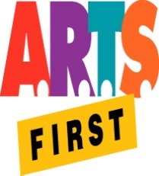 | Hawai‘i State Foundation on Culture & the Arts  Artists in the Schools Program  Partnership Grant Application Form  SY 2019-2020  SIGNATURE FORM | 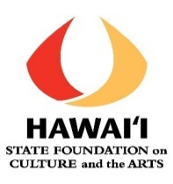

School Name: __________________________________________________________

Principal Statement of Support
I approve this final partnership application, including the grant request and school share amounts.

If the partnership receives an AITS grant, I certify that my school will contribute 10% of the AITS grant amount received, in cash (not in-kind), towards residency expenses, unless this is an AITS Art in Public Places (APP) application, in which case, there is no cash contribution required from the school.

I will ensure that any school share payable to the Artist is processed in a timely manner.

I understand that a one-hour professional development session with the artist is required for the residency teachers.

I recognize that the whole residency serves as professional development for the faculty, so I will not pull teachers out of their classes during AITS time unless absolutely necessary.

I will ensure that all residency online final reporting is completed 30 days after the end of the residency or by May 31, 2020, whichever is earliest.

I will thank the representative(s) and senator(s) from the school’s district in writing (c: HSFCA) and invite them to observe some part of the residency.

___________________________________________________________________________
Principal’s Signature Date

Principal’s Printed Name

Additional Comments:

