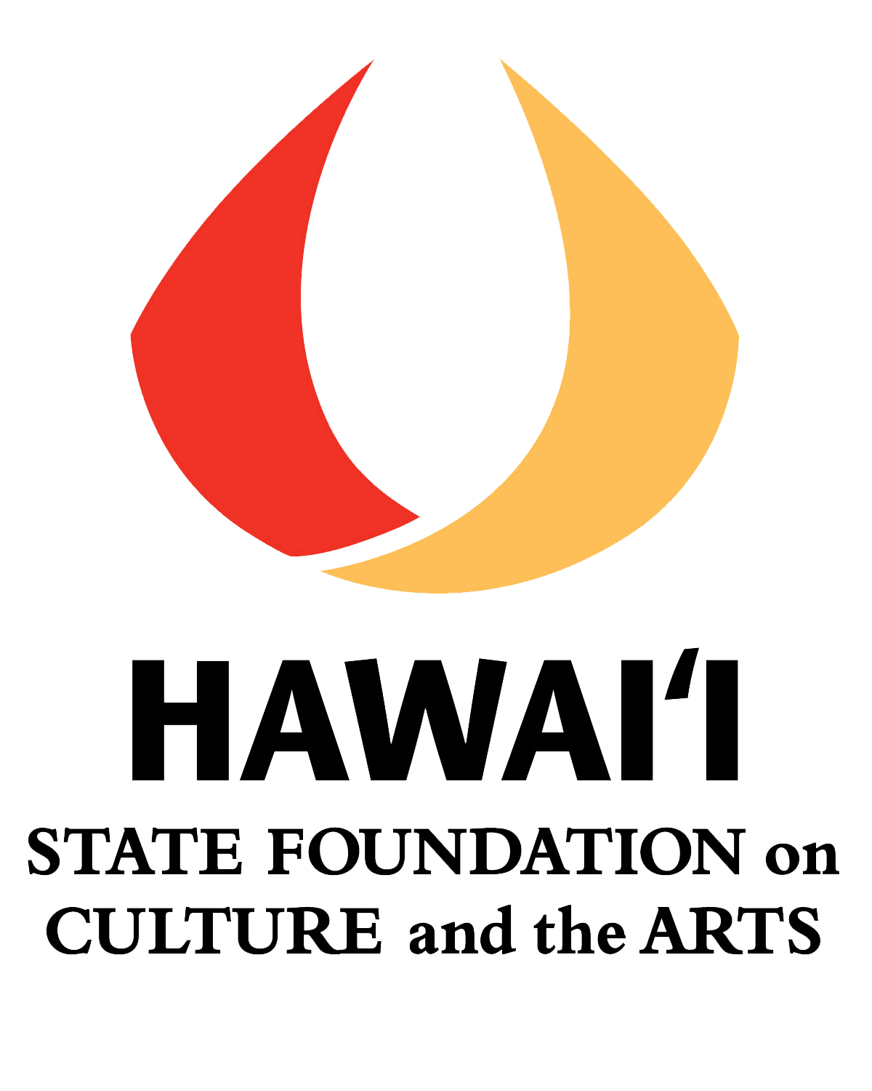
Hawai’i State Foundation on Culture and the Arts
Art Bento Program at HiSAM
Application Information (SY 2020-2120)

TITLE: | Hawai‘i State Foundation on Culture and the Arts  Art Bento Program at HiSAM (2020-21)
PURPOSE: | To provide a standards and inquiry-based museum education program for Grades 2 to 6 students and their teachers. Art Bento’s theme, “Responding to Art,” connects to current art standards and ELA Common Core Standards. Activities enliven participants’ understanding of art as a tool for developing critical thinking skills and visual literacy. Teachers learn inquiry-based strategies to facilitate engaged learning through observation and conversation.  The program utilizes works of art from the SFCA’s Art in Public Places Collection at HiSAM.
ELIGIBILITY: | All O‘ahu elementary public and charter schools are eligible. At the time of application, a school must have been in operation, providing services to its students, for a minimum of one semester. First time applications may take precedence over those from schools that have participated two years in a row. Schools will be notified of the selection results by late May.
REQUIREMENTS FOR SCHOOL SELECTION | For the 2020-21 school year, schools will be selected based on the following requirements:  - A minimum of six classes is required to participate in the Art Bento Program at HiSAM. Classes must be grouped by grade level, i.e. (3) Grade 4 classes, (3) Grade 5 classes.  - Only one application per school with a maximum of 12 classes to be served.  - Commitment from administration and participating faculty to:  - Designate a staff person to be point of contact for the school and coordinate the residency schedule and deliverables. The required Instructional time per class is 45-60 minutes for pre and post visits and half-a-day for the museum field trip;  - Designate a classroom space where the teaching artist can establish a “residency” to do the art activities. Please note – visual arts sessions require tables and a sink, poetry requires tables, while dance, drama, and music require an open cleared space to comfortably fit all participants;  - Schedule a 1.5 hour mandatory time block for all participating teachers. This is a 30 minute orientation session and an hour-long professional development led by a Teaching Artist, as part of the Art Bento Program at HiSAM residency, prior to sessions with students;  - Participate fully in all residency activities as well as facilitate three discussions with students based on art reproductions provided by the Art Bento Program. Participating teachers will complete and submit a Response to Art Worksheet for each discussion;  - Notify the state representative and senator from the school’s district, in writing, of the receipt of an Art Bento residency. The notification should thank the legislators for funding the Art Bento Program through support for the SFCA’s Art in Public Places Program, and invite the legislators to observe some part of the Art Bento residency. A copy of the notification shall be provided to the Art Bento Program Coordinator;  - Complete a final online program evaluation – due 2 weeks after residency ends.
Application Contents | Please complete and submit the application contents. Use the templates provided:  - School Profile with Principal and Contact Teacher signatures  - Narrative  If you are applying for the first time, please view the Art Bento Program Presentation at http://sfca.hawaii.gov/grants-programs/art-bento/.  Note: For repeat schools, we highly recommend that a teacher experienced with the Art Bento Program write the application in collaboration with other teachers expected to participate.  Application forms are available at Hawai‘i Arts Alliance website: www.hawaiiartsalliance.org and at the SFCA website: www.hawaii.gov/sfca/forms. Applications as a word document may be obtained by emailing Loke Simon – loke@hawaiiartsalliance.org
APPLICATION DUE DATE | FRIDAY, March 6, 2020, 4:00 pm HST  NOTE: If your school is applying for the 1st or 2nd year and you would like feedback on your application before final submission, please email this document to loke@hawaiiartsalliance.org by February 21, 2020.  Application may be submitted via email in PDF, mail, or fax to:  Loke Simon, Hawai‘i Arts Alliance  P.O. Box 3948, Honolulu, HI 96812-3948  Telephone No. 533-2787  FAX No. 526-9040  E-mail: loke@hawaiiartsalliance.org

Download Art Bento Program at HiSAM forms at www.hawaiiartsalliance.org or hawaii.gov/sfca/forms. Email loke@hawaiiartsalliance.org to request forms.

Hawai‘i State Foundation on Culture and the Arts
Art Bento Program @ HiSAM
APPLICATION FORM SY 2020-21

Instructions: Please use this form. Type your information and answers in the writeable Word boxes and/or designated spaces for each question. The boxes will expand. Font size should be no smaller than Arial 10.
Note: We highly recommend a ”team approach” when completing this form with the participation/input of at least one representative from each grade level applying.

School Profile
School: | District:
Mailing Address: | Telephone:
Principal:
Email:
Contact Person/Lead Teacher:
Email:
SASA:
Please check if you are a Title I School: , % of students free/reduced lunch ______
Has your school participated in the following programs in the past 3 years (SY17-18, SY18-19, SY19-20)?
- Artists in the Schools Program (AITS) - Yes No
Most recent year? _________ Grades that Participated: ______________________

- ARTS FIRST Summer Institute - Yes No
What year? ____________ No. of Teachers who attended: ___________

- HSFCA Artist in Residence (AIR) - Yes No Not sure
What year? _________

- Art Bento Program @ HiSAM - Yes No
What years or most recent year? _______ Grades that Participated: _____________________

I agree to all the program requirements as stated on the Application Information Sheet.
We have watched the Art Bento Program Presentation PowerPoint on the SFCA website.
Principal’s Signature:
Contact/Lead Teacher Signature:
Date:

NARRATIVE

Please answer the following questions. The boxes below will expand as you type in them.
Note: Each of the questions, #2 – 6, is worth 5 points. Please refer to the rubric provided.

- Please list and identify the grade levels/and the number of classes that are committed to participating in the Art Bento Program. (Minimum 6 classes, maximum 12).

- How does participating in the arts benefit student learning? How do your teachers implement arts learning in their classrooms? Please cite specific examples. (Worth 5 points)

- For 1st time applying schools: Read/Review the Art Bento flier and PowerPoint carefully and cite two ways in which this inquiry-based program will benefit your teachers and students and/or align with your school’s goals.
For repeating schools: 1. What have students and teachers gained as a result of past participation in the program? 2. How have you incorporated open-ended questioning, facilitated conversations and visual text/images into your teaching and/or curriculum as a result of that participation? 3. How will further participation benefit your students and teachers?
Please cite specific examples. (Worth 5 points)

- How will your teachers and administration ensure full participation in each segment of this program and support the fulfillment of the program requirements? (Worth 5 points)

- Define the space(s) your school has available and will reserve exclusively for the Visual OR Performing Teaching Artist’s use throughout the Art Bento residency [Pre Visit, Post Visit]. Visual: sink and preferably linoleum floor. Performing: clean, open, and preferably carpeted space. Describe your school’s capacity for providing appropriate DESIGNATED space for each (Visual/Performing). (Worth 5 points)

- Additional information you may wish to include to support your application: (worth 5 points)

NOTE: If your school is applying for the 1st or 2nd year and you would like feedback on your application before final submission, please email this document to loke@hawaiiartsalliance.org by February 21, 2020.
FINAL submission of application is March 6, 2020, 4:00 pm HST.

