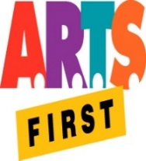 | State Foundation on Culture & the Arts  Artists in the Schools Program  Partnership Grant Application SY 2022-2023  SIGNATURE FORM | 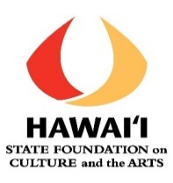

School Name: __________________________________________________________

Principal Statement of Support
I approve this final partnership application, including the grant request and school share amounts.

I understand that contributions are not required.If the partnership receives an AITS grant, I certify that my school will contribute the amount stated in the grant.

I will ensure that any school share payable to the Artist is processed in a timely manner.

I understand that a professional development session led by the teaching artist for the classroom teachers in optional, however if the application includes professional development, I will ensure that the teachers and teaching artists have time, space and support for it to occur.

I recognize that the whole residency serves as professional development for the faculty, so I will not pull teachers out of their classes during AITS time unless absolutely necessary.

I will ensure that all residency online final reporting is submitted 30 days after the completion of the project or 30 days after the end of the contract, whichever is earliest.

I will thank the representative(s) and senator(s) from the school’s district in writing (copy to SFCA) and invite them to observe some part of the residency.

___________________________________________________________________________
Principal’s Signature Date

Principal’s Printed Name

Additional Comments:

