State Foundation on Culture and the Arts
Artists in the Schools Program
Grant Application

GO SMART ONLINE INSTRUCTIONS


The School is the applicant for the Artists in the Schools grant.
Each applicant School MUST have or create a Profile that is used year after year BEFORE starting an AITS Application.
This includes the Username and Password for the School, which is shared amongst all who are inputting the applicant and application information.

STEP ONE: GO Smart Online Website Login
https://hawaii.gosmart.org/

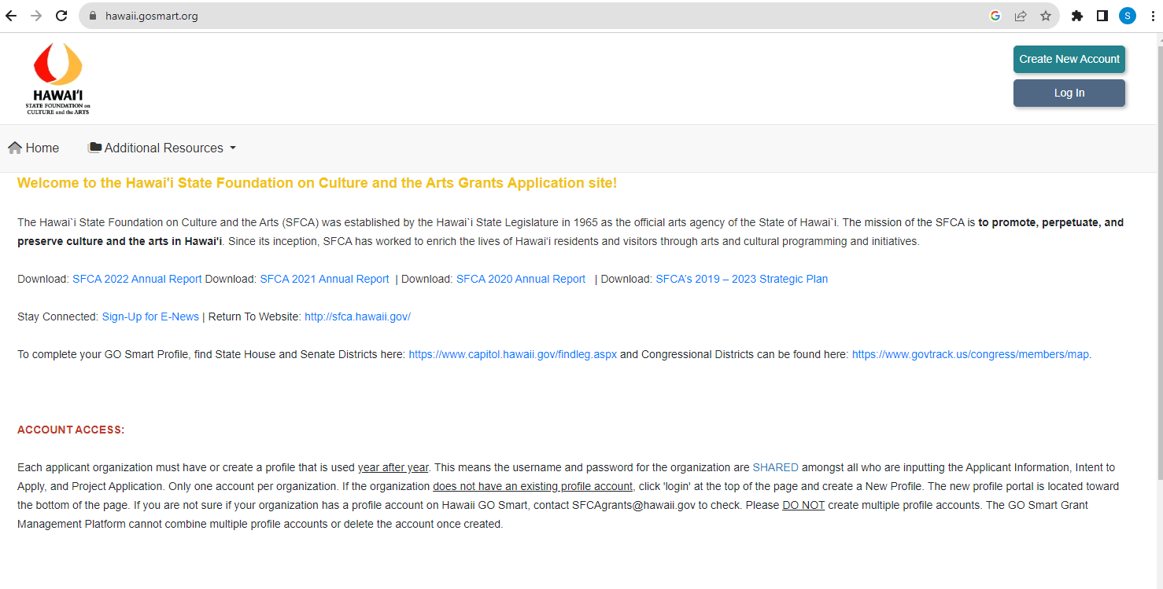

STEP TWO: Enter School’s Username and Password
On this page, you can:
- Login with your School’s Username and Password that your School already has (see STEP THREE below), OR
- Reset your Password, OR
- Create a new profile - for Schools that have never used GO Smart online application (see STEP FOUR below).

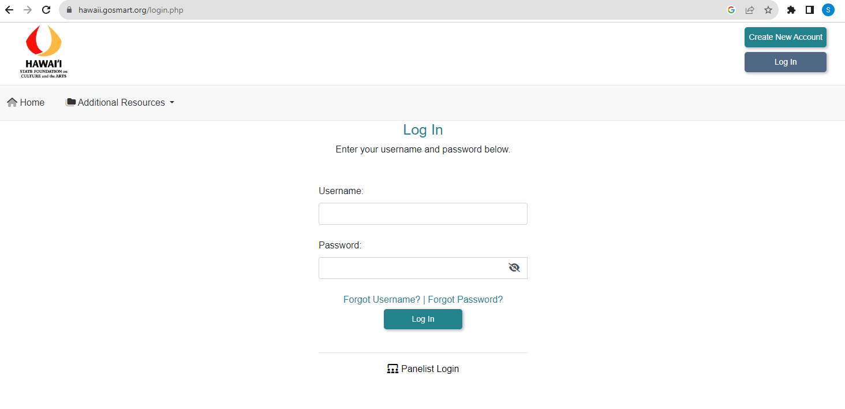

STEP THREE: For Schools that already have a Username and Password.
If your school applied for a previous AITS grant, please check with your AITS Contact person at your school or the ATP for your residency for the username and password:
Use your most current username and password.
Usernames and passwords can be reset on the GO Smart login page using the email associated with the account.
Please contact Danica.rosengren@hawaii.gov if you are unsure about your username or password, or if you have any questions about your Go Smart school profile and registration.
STEP FOUR: For Schools that need to create a Username and Password.
If this is the first time that your School is applying for an AITS grant via the GO Smart online application system, you must create an online profile:
If you are not sure whether this is the first time that your school is applying for AITS via the GO Smart online, please contact Danica.rosengren@hawaii.gov.
Applicants can create a new profile by clicking “Create New Account” in the top right corner of the home page.
- “GO Smart End User Terms and Conditions” will appear – click “Yes, I Agree”.
- You will need to answer a series of applicant PROFILE questions – follow the directions below, under STEP FIVE.

STEP FIVE: Profile Section.
The Profile section is a pre-existing GO Smart template that we cannot change. Please follow the directions below so that we have the correct information for your School. The required fields are marked with an asterisk.
Formatted text is not accepted by GO Smart; applicants cannot bold, italicize or underline text or change font style or size.
Profile Page Fields | Your Selection or Answer
* Type of Profile you are creating | Choose “Organization”
PRIMARY CONTACT INFORMATION:
* Username | Enter a username for your school
* Password | Enter your School’s Password
* Confirm Password | Enter your School’s Password again
*First Name | Write a shortened version name of your school, such as “Kuhio”
*Last Name | Write the grade levels of the school, such as “Intermediate” or “Elementary”
* Email | Enter Email Address at which you wish to receive AITS notifications (this may be updated from year to year, but should be the school contact, not the Teaching Artist Partner)
* Confirm Email | Enter Email Address again
CONTACT INFORMATION:
* Legal Name | Enter full School name, e.g., “Prince Jonah Kuhio Elementary School”
* Phone | Enter School Phone Number again with area code (e.g., 808-123-4567)
* Address | Enter School mailing address
* City | For School mailing address
* Country | Choose “United States”
* State/Province | Choose “Hawaii”
* Postal Code | For School mailing address
*Website | Add the web address for the school
ADDITIONAL INFORMATION:
* Organization Type | Choose “Other School”
* Applicant Status | Choose “None of the Above”
* Applicant Discipline | Choose “Multidisciplinary”
FEIN/Tax ID | Enter all zeros – “00-0000000”
Mission Statement | Write the Schoolʻs mission statement
* Date Organization Formed | Enter the date of the school was formed
Unique Entity ID (UEI) | Please add the schools UEI. If you have questions, email danica.rosengren@hawaii.gov
* Congressional District | Enter Your District Number found at https://www.capitol.hawaii.gov/findleg.aspx
* State House District | Enter Your House District Number found at https://www.capitol.hawaii.gov/findleg.aspx
* State Senate District | Enter Your Senate District Number found at https://www.capitol.hawaii.gov/findleg.aspx
Click on the blue UPDATE button at the bottom to save your answers.

To Edit Profile
If you need to update your School’s Profile:
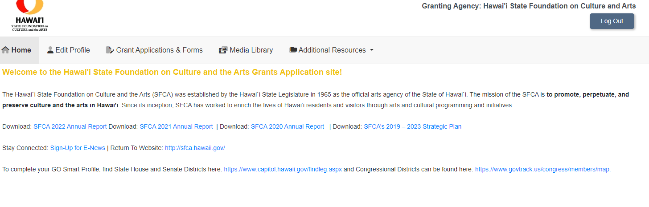

Some reasons for editing your school’s profile:
- To update the Primary Contact email.
- To update the password.
- To update the school’s mailing address.

STEP SIX: To Work on the AITS Application
Click on “Grant Applications & Forms” on the menu bar.

Scroll down to Artists in the Schools (AITS) 2026-2027
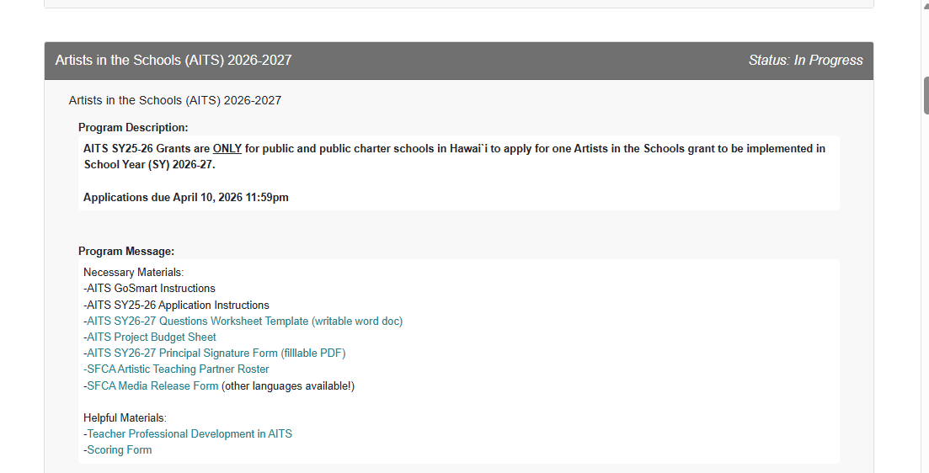

Click “Start” to start a new application. This button will turn yellow and say “Edit” after you have started your application or to continue your application.
Filling in the Answers
Within the GO Smart system, applicants are presented with a series of questions and requests for information.
Some of these questions and requests require applicants to use check boxes and drop-down selection screens and others require a narrative response.
Use the AITS SY2026 Questions Worksheet Template (writable word document) to develop your answers. Copy and Paste completed narrative responses into the GO Smart application. You will not submit this worksheet. This is to help the school’s AITS Contact and the ATP who are working together to develop the residency.

Use the Program Budget Sheet to develop your residency budget for the school.
You will submit this worksheet, in the “File Upload” of the budget section. A link to the Program Budget Sheet is also on the budget page.
Once the application is submitted, applications cannot be revised.

Helpful Hints
Here are some general suggestions to help applicants navigate the GO Smart application process:
- Multiple Users - To avoid losing work, ensure that only 1 person is working on the application at any given time. Multiple users should communicate frequently with each other.
- GO Smart “times out” if an applicant remains on one page for an extended period of time. To avoid losing work, save often using the “Save Work” button at the bottom of each page.
- Applicants must use the TAB key or MOUSE to move from question to question. When an applicant hits “enter,” the system will save the page, but will not move to the next question.
- Narrative responses are limited to a maximum character (not word) count, including spaces. Applicants will be notified on each question if the maximum character count has been exceeded.
- Formatted text is not accepted by GO Smart; applicants cannot bold, italicize or underline text or change font style or size.
- Do not use Hawaiian diacritical marks. GO Smart cannot handle it – the automated substitutions are unintelligible.
- Many of the Questions require that you answer them. Click “Did I Complete This Page?” at the bottom to check on the page you were working on.
- If you would like to see or have a PDF of your application in progress, click on “View PDF” at the bottom.
- To move to the next section of the application, click “Next” on the bottom right of the page.

For Technical HELP

Scroll to the bottom of the page and click on “Help Center.”
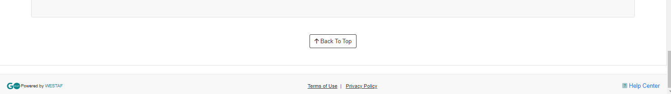

When you click on “Help Center,” it will take you to this page, with many additional resources.
