JOSH GREEN, M.D.  GOVERNOR  KE KIAʻĀINA | 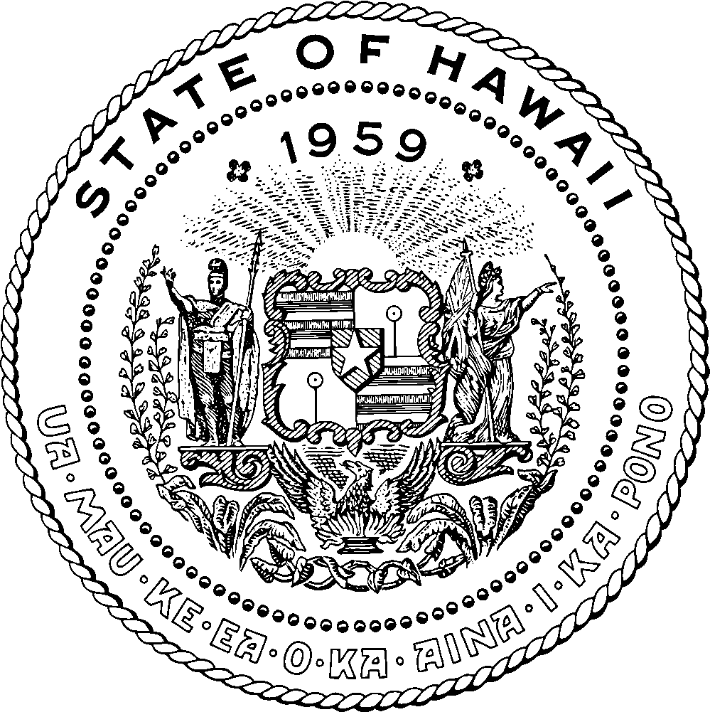 | KEITH A. REGAN  COMPTROLLER  KA LUNA HOʻOMALU HANA LAULĀ  MEOH-LENG SILLIMAN  DEPUTY COMPTROLLER  KA HOPE LUNA HOʻOMALU HANA LAULĀ
STATE OF HAWAIʻI | KA MOKUʻĀINA O HAWAIʻI
DEPARTMENT OF ACCOUNTING AND GENERAL SERVICES | KA ʻOIHANA LOIHELU A LAWELAWE LAULĀ
P.O. BOX 119, HONOLULU, HAWAII 96810-0119

King Kamehameha Celebration Commission Meeting Minutes

Date: Tuesday, April 14, 2026
Time: 6:00 p.m.
Place: Zoom and State Foundation on Culture and the Arts Multipurpose Room

Commission Attendees Per Roll Call: Beverly Lee (Association of Hawaiian Civic Clubs), Ikaika Bantolina (Royal Order of Kamehameha), Louise Alina (‘Ahahui Ka‘ahumanu), Kimo Alama Keaulana (Kapahulu Music Club), Jame Schaedel (Kamehameha Schools Alumni Association, Kalei Hoffman (Island of Kauaʻi), Leināʻala Lopez (Island of Molokaʻi), Puakeʻala Mann (Daughters and Sons of Hawaiian Warriors - Māmakakaua)

Commissioners not present: Vacant (Papakōlea Community Association), Vacant (Island of Hawaiʻi), Pamela Alconcel (Island of Lānaʻi), Moanike‘ala Whittle-Wagner (Island of Maui), Ian Custino (Hale O Nā Aliʻi), Kehaulani Keanaʻaina (Daughters of Hawaiʻi), Leilani Kahoano, (Waimānalo Hawaiian Homestead Association)

Call to Order, Roll Call and Reminders, Establish Quorum -- Chair Beverly Lee called the meeting to order at 6:12 p.m. and established quorum. The February and March Meeting Minutes were approved. Typo in V, b on February Minutes should be spaghetti and in March section II spelling in 3rd sentence down should be installation.

- Public Testimony -- Nothing to report.
- Executive Director’s Report (Amy Hammond) -- She continues to carry out her regular duties and responsibilities, including informing Commissioners of upcoming matters such as HB2118, HD2, relating to the transfer of the King Kamehameha Celebration Commission (KKCC) to the Department of Business, Economic Development and Tourism (DBEDT), as well as GM216 confirming Zachary Ikaika Bantolina to the Commission. On March 23, Amy testified before the legislature regarding HB2118, HD2. The measure passed, and as a result, the KKCC and SFCA departments will be transferred to DBEDT. It is anticipated that there will be approximately a one-year transition period to allow for all details to be properly addressed. Once a final transfer date is confirmed, the Commission will be notified. At present, the listed date of July 1, 3000 is a placeholder commonly used by the Hawaiʻi State Legislature. During the hearing, Senator DeCoite inquired whether there would be any objections to a potential transfer to OHA. Amy responded that she would need to consult with the Commission, as she reports on their behalf, but acknowledged that the current intent of the transfer to DBEDT is to provide administrative support while ensuring cultural integrity is maintained. Senator Inouye also commented that the Commission should continue to seek support from OHA. In addition, follow-up was conducted regarding the confirmation of Ikaika Bantolina by providing a letter of support and coordinating with the Commission and SFCA to submit testimony. On March 23, 2026, he was confirmed to a term expiring June 30, 2029. She is also preparing for the Lei Draping Ceremony, which she is leading, and has been participating in parade planning meetings for Oʻahu. Responsibilities include securing and producing all radio and print advertising, managing public relations, and working to secure Mana Maoli for social media support. Additional responsibilities include following up on the installation of new floor tile on the second floor of the annex, where existing tile has been removed and new installation is being scheduled. A meeting was held with Diane Ako, DAGS Communications Officer, to review the position. Following this discussion, Diane requested Amy’s participation in a segment for internal publication titled “This is DAGS,” which highlights various roles and responsibilities within the department. The proposed filming is scheduled for next Wednesday. Amy will obtain the questions in advance for review and will discuss participation with the Executive Committee prior to filming.
- Financial Report (Amy Hammond) -- The grant funds from the State Foundation on Culture and the Arts were transferred to the King Kamehameha Celebration Commission Trust Fund at the beginning of March and Amy issued the procurement in early March for a contractor to handle the Oʻahu Lei Draping Ceremony and process the statewide marketing and advertising payments. The procurement has been awarded to Kala Foundation in the amount of $60,000. Kimo suggested that we try to gather the spreadsheets for the related expenses to the activities for at least the last 5 years as if we are transferred to DBEDT they may request this information. He suggested that moving forward we have this information in the future. Amy reported that this was done when we received funds from HTA but that each island manages their operation independently and it is difficult if not impossible to demand this from each island volunteer organization as we are not providing them funding. Kimo noted we need to have a better handle on how funds received are managed. Kimo voiced his concern that he would not support OHA overseeing the Commission. Jame noted that HB2118 died on Friday as it did not receive a hearing in the Senate Ways and Means Committee. Jame suggested that we should strategize to see if Representative Kapela will reintroduce the bill. We should determine the Commission position before next session, Jame agreed that he would not recommend us transferring to OHA. Jame reiterated that Ikaika will still need to be approved by the Senate. Amy reiterated that if any Commissioner receives a notification, please do share with us as the notification function is malfunctioning. Amy contacted Chris Lee’s office who advised that they are not going to notify anyone. Amy further noted that with regard to Kimo’s concerns about accountability of funding status that we need to get a clear mission and notify everyone we work with on the expectation if it is changing for the future as several organization have already indicated that they do not intend to provide this information so we would need to work out an agreement with them moving forward if we want to change the mode of operation.
- KKCC Business/Committee Reports
  - Executive Committee Report (Beverly Lee) -- Beverly reported that if we are transferring that would be in the future. Beverly also noted that in the past there was a Roles and Responsibility document that was begun by Kainoa Daines but was not completed. Beverly would like to open the document to the Commissioners as to how to proceed. How to make the Commission better and how to help each other. Beverly would like to ask everyone to review the document and will share this document with everyone. Kimo noted that the document should be shared and everyone can update the information in the form of a spreadsheet. He also suggested that we might want to consider some additional seats as well in the future. Jame suggested that we create a Permitted Interaction Group (PIG) which would need to be added to the agenda. The document could be sent out as a BCC with all our thoughts collected and coalited. Amy added that this information is more an onboarding administrative information than functional in nature as it relates to the Commission. Beverly noted she would like everyone to weigh in on the documents moving forward. Moving forward Beverly was able to get the state to pay for the new 18 naupaka plants that will be installed she will follow up with regards to the timing. Beverly inquired about the King Kamehameha Legacy Hoʻolauleʻa happening in Las Vegas in conjunction with the Boyd Hotel; it has now been relocated to the New Orleans Hotel and will happen on the 18 and 19 of June. Ken Makuakane has even suggested that there also be an Aliʻi Sunday as well. Also, the Royal Order of Kamehameha has also been invited. Kimo noted that they mean well but suggested that we do not get involved in the programming. Beverly noted that the purpose was to bring all the mainland kanaka together. Puakeʻala suggested that they seek approval before using the image of King Kamehameha. Amy will send a letter notifying about the image usage if appropriate but will refer to the statute prior. Jame noted that we might consider advertising it on our website as a show of support.
  - Legislative (Vacant) -- Beverly followed up with Manu Powers who advised that she will no longer be chairing the Legislative Committee. Jame has advised he will consider acting as the Legislative Chair possibly in the next few months.
  - Statuary (Kimo Alama Keaulana) -- Nothing to report.
  - Retention (Kēhaulani Keanaʻaina) -- Beverly and Amy spoke regarding the retention status. Beverly noted she received the information from Wendy Kondo and will be comparing.
  - State Archives (Kimo Alama Keaulana) -- Ron Williams from the Archives has started a virtual online course on Kamehameha III and you can reach out to Ron regarding participation for the Sunday events.
  - Friends of KKCC (Moani Whittle-Wagner) -- Nothing to report.
  - Outreach and Education (Ikaika Bantolina) -- Ikaika noted he will provide a more detailed report following this year’s celebrations.
- Events -- General update on All island-wide events
  - Kauaʻi Parade and Hoʻolauleʻa (Kalei Hoffman) -- Kalei noted that they are doing a fundraiser on May 2 called Lei of Laughs featuring local comedians. The tickets range from $60 - $100. The Parade date will be on Saturday, June 13. Kalei noted that they held a workshop for the pāʻū riders where they shared a great deal of information about horsemanship.
  - Oʻahu, Parade, Hoʻolauleʻa, Pāʻū (Clint Kalaola, Oʻahu Parade Chair and Hoʻolauleʻa Chair) -- Clint responded to Kimoʻs inquiry as to who is participating in the parade and that the applications are open. The cut off date is around May 20 for completion of application. Once the applications are closed we can distribute the participation list. He noted that everything is on track for the Parade and Hoʻolauleʻa. Clint commented that things such as transportation will need to happen closer to the event. Beverly has 8 full pa’u units. Bev noted that the Pau queen may have a float or trolley. Pau Marshall is Ernie Yuen and is flying in from Florida.
  - Oʻahu Statue Lei Draping/Practice Dates; Wednesday, June 3 and Monday, June 8, 2026, from 4:30 pm - 6:30 pm each day (Louise Alina) -- Lousie noted that she has ordered everything she needs to order and ready for Lei Draping. Can we give a shout out to the local community to bring the yellow plumerias for the event in which they can drop off. She advised that we may have some issues with the plumeria this year due to the weather. We can work on putting out a media request. Kimo noted that Waianae may have. We need about 15,000 blossoms and used to pay .08 cents now the wholesalers are asking .28 cents per blossom. Kimo noted that he will ask around. In the past Louise has been using Dora at the airport. We used to get the plumeria from Molokaʻi but the cost got too expensive. Kimo noted Punahou gets their flowers from Kahuku for their events as they order by the thousands.
  - Molokaʻi Gala/Hoʻolauleʻa (Leināʻala Lopez) -- Leināʻala met with Tylor and the date of the events has been changed to June 12 and 13 because Kaumakaiwa Kanaka‘ole is available to perform at that time. She noted that the Gala will be held on Friday, June 12 at the Community Health Center on Friday and the Hoʻolauleʻa on Saturday, June 13. Leināʻala inquired if they need to submit their budget since each island is approaching their funding independently. Kimo suggested that once they reconcile, they provide a copy of their budget. She noted that she can have Daryl forward a copy once completed.
  - Maui Parade/Hoʻolauleʻa (Moanikeʻala Whittle-Wagner) -- Amy reported on behalf of Moani that due to recent weather effecting UHMC where we hold our meetings we have had to cancel recent meetings. She is in communication with all of the princesses and everyone doing their best to holomua. April 25 is the upcoming horsemanship workshop at Tom Morrow Stadium. and a May 2 community workday at Puʻu Kukui.
  - Lānaʻi (Pam Alconel) -- Nothing to report.
  - Island of Hawaiʻi -- Hilo Lei Draping and Kohala Lei Draping/Parade/ Hoʻolauleʻa (Vacant) -- Nothing to report.
  - Kona Parade and Hoʻolauleʻa (Kēhaulani Keana‘aina) -- Nothing to report.
- Commissioner reports/updates non-island specific representatives
  - Royal Order of Kamehameha (Ikaika Bantolina) -- Nothing to report.
  - ʻAhahui Ka‘ahumanu (Louise Alina) -- Nothing to report.
  - Hale O Nā Ali‘i O Hawaiʻi (Ian Custino) -- Nothing to report.
  - Daughters & Sons of Hawaiian Warriors, Māmakakaua (Puake‘ala Mann) -- Nothing to report.
  - Daughters of Hawai‘i (Kēhaulani Keana‘aina) -- Nothing to report.
  - Association of Hawaiian Civic Clubs (Beverly Lee) -- Nothing to report.
  - Kamehameha Schools Alumni Association (Jame Schaedel) – Jame noted board members are looking forward to the upcoming Alumni Week.
  - Kapahulu Music Club (Kimo Alama Keaulana) -- Kimo noted that they renewed their Department of Commerce and Consumer Affairs information. He noted that Kainoa Miguel will be joining as an additional wrapper and have an additional person to assit pāʻū riders with mounting.
  - Waimānalo Hawaiian Homes Association (Leilani Kahaono) -- Nothing to report.
  - Papakōlea Community Association (Vacant) -- Nothing to report.
  - Island of Hawaiʻi (Vacant) -- Nothing to report.
  - Island of Maui (Moanikeʻala Whittle-Wagner) -- Nothing to report.
  - Island of Kauaʻi (Kalei Hoffman) -- Kalei inquired if they could make t-shirts and use the statue image on their artwork. Beverly has been reviewing the images for t-shirts to be sure they are respectful. Kimo noted that culturally one would not put their head above the image of King Kamehameha and suggested that they may want to consider not having King Kamehameha with Kaumualiʻi next to each other. We will need to get an opinion from the Attorney General on approval of the image of the statue.
  - Island of Molokaʻi (Leinaʻala Bishaw) -- Nothing to report.
  - Island of Lānaʻi (Pam Alconel) -- Nothing to report.
- Public Testimony -- Nothing to report.
- Miscellaneous
- Upcoming Meeting -- The next meeting is currently scheduled for 6 p.m. Tuesday, May 12, 2026.
- Adjourn -- The meeting was adjourned at 7:44 p.m.

