JOSH GREEN, M.D.  GOVERNOR  KE KIAʻĀINA | 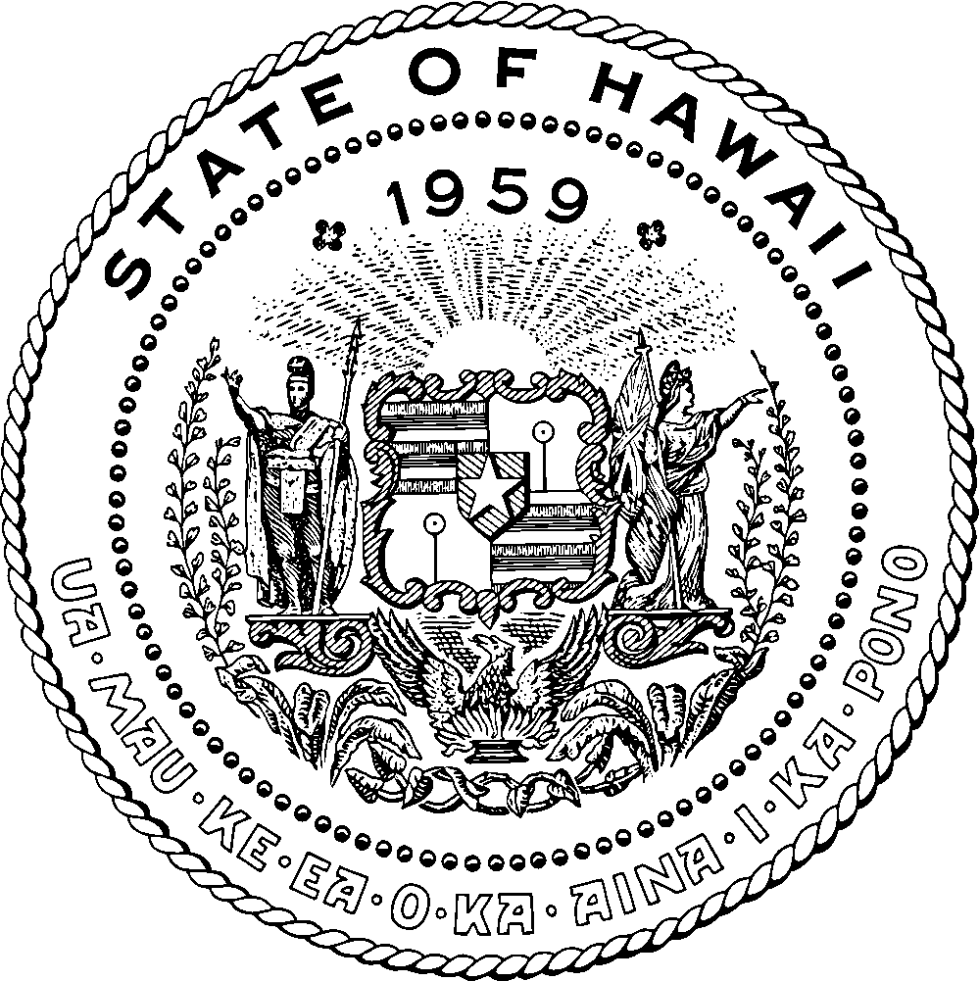 | KEITH A. REGAN  COMPTROLLER  KA LUNA HOʻOMALU HANA LAULĀ  MEOH-LENG SILLIMAN  DEPUTY COMPTROLLER  KA HOPE LUNA HOʻOMALU HANA LAULĀ
STATE OF HAWAIʻI | KA MOKUʻĀINA O HAWAIʻI
DEPARTMENT OF ACCOUNTING AND GENERAL SERVICES | KA ʻOIHANA LOIHELU A LAWELAWE LAULĀ
P.O. BOX 119, HONOLULU, HAWAII 96810-0119

King Kamehameha Celebration Commission Meeting Minutes

Date: Tuesday, May 12, 2026
Time: 6:00 p.m.
Place: Zoom and State Foundation on Culture and the Arts Multipurpose Room

Commission Attendees Per Roll Call: Beverly Lee (Association of Hawaiian Civic Clubs), Ikaika Bantolina (Royal Order of Kamehameha), Louise Alina (‘Ahahui Ka‘ahumanu), Kimo Alama Keaulana (Kapahulu Music Club), Jame Schaedel (Kamehameha Schools Alumni Association, Puakeʻala Mann (Daughters and Sons of Hawaiian Warriors - Māmakakaua), Moanike‘ala Whittle-Wagner (Island of Maui), Leilani Kahoano, (Waimānalo Hawaiian Homestead Association), Ian Custino (Hale O Nā Aliʻi), Ian Custino (Hale O Nā Aliʻi), Kalei Hoffman (Island of Kauaʻi)

Attendees: Lokelani Hooton (Chair Kohala King Kamehameha Parade), Clint Kalaola (Kala Foundation)

Commissioners not present: Vacant (Papakōlea Community Association), Vacant (Island of Hawaiʻi), Pamela Alconcel (Island of Lānaʻi), Kehaulani Keanaʻaina (Daughters of Hawaiʻi), Leināʻala Lopez (Island of Molokaʻi)

Call to Order, Roll Call and Reminders, Establish Quorum -- Chair Beverly Lee called the meeting to order at 6:01 p.m. and established quorum. February and March meeting minutes were provided with the corrections noted from last meeting included and are also posted to the website. The April Meeting Minutes were approved.

- Public Testimony -- Nothing to report.
- Executive Director’s Report (Amy Hammond) -- She continues to carry out her regular duties and responsibilities, including informing Commissioners of upcoming matters such as HB2118, HD2, relating to the transfer of the King Kamehameha Celebration Commission (KKCC) to the Department of Business, Economic Development and Tourism (DBEDT) which was approved. The transfer may take place as soon as July. She is also preparing for the Lei Draping Ceremony, which she is leading, and has been participating in parade planning activities for Oʻahu. Responsibilities include securing and producing all radio and print advertising, managing public relations, and securing Mana Maoli for social media support. Additional responsibilities include following up on the installation of new floor tile on the second floor of the annex, where existing tile has been removed and new installation has been delayed until further notice. It was decided after the last meeting to put this possible “This is DAGS,” which highlights various roles and responsibilities within the department on hold until later in the year. It was noted that the Director of DAGS, Keith Regan, has been appointed as the Lieutenant Governor. KKCC will continue to report to DAGS until further notice.
- Financial Report (Amy Hammond) -- Amy reported that we are awaiting the invoice from Kala Foundation and once the events are executed the State will process their payment check.
- KKCC Business/Committee Reports
  - Executive Committee Report (Beverly Lee) -- Beverly advised she has been working with Amy closely on variety of projects. In addition, she reported that she is awaiting information regarding the naupaka as there are areas that are bare.
  - Legislative (Vacant) -- We are awaiting confirmation of a Committee Chair soon.
  - Statuary (Kimo Alama Keaulana) -- Nothing to report.
  - Retention (Kēhaulani Keanaʻaina) -- Beverly noted she has been working with Kēhaulani regarding the retention status. She is comparing the charts and will reach out directly to each Commissioner. Barbara Nobriga passed away and Kēhau has been busy as she jumped into assist with the Kona Parade.
  - State Archives (Kimo Alama Keaulana) -- Nothing to report.
  - Friends of KKCC (Moani Whittle-Wagner) -- Nothing to report.
  - Outreach and Education (Ikaika Bantolina) -- Ikaika noted he will provide a more detailed report following this year’s celebrations.
- Events -- General update on All island-wide events
  - Kauaʻi Parade and Hoʻolauleʻa (Kalei Hoffman) -- Kalei noted that they had a very successful fundraiser called Lei of Laughs which happened last Saturday and and they hope to have some additional events in the future. She has a referral of Shawna Kaleikukui who is a potential Commissioner on Hawaiʻi Island.
  - Oʻahu, Parade, Hoʻolauleʻa, Pāʻū (Clint Kalaola, Oʻahu Parade Chair and Hoʻolauleʻa Chair) -- Clint noted that we have the general Parade Meeting Coming up and the deadline to apply to participate in the Parade has been extended and the cutoff date is around May 20 for completion of application. Beverly has eight full pāʻū units. Bev noted that the Pāʻū Queen may have a float or trolley. Pāʻū Marshal is Ernie Yuen and may have a trolley, he is flying in from Florida. The Grand Marshal is Richard “Babe” Bell and his family will ride in honor of him. The Mōʻī has been selected and notified with name released shortly. Hoʻolauleʻa will be happening following parade at Kapiolani Park.
  - Oʻahu Statue Lei Draping/Practice Dates; Wednesday, June 3 and Monday, June 8, 2026, from 4:30 pm - 6:30 pm each day (Louise Alina) -- Lousie noted that she has ordered everything she needs to order and ready for Lei Draping. She thanked Kimo for the phone number for the farmer. As usual, she will need the water hose and parking. She suggested we should put out an announcement the week prior to the Lei Draping requesting the public to bring plumeria for lei stringing.
  - Molokaʻi Gala/Hoʻolauleʻa (Leināʻala Lopez) -- Nothing to report.
  - Maui Parade/Hoʻolauleʻa (Moanikeʻala Whittle-Wagner) -- Moani reported that all eight islands are full and they had a horsemenship workshop with 40 people that showed up and a unit with all of their horses which took place at Tom Morrow Equestrian Center. At Puʻu Kukui they have planted more flowers and now are able to go and pick. Daryl has put out the PSA’s for the last month and has been getting a good response for participation. Currently viewers are only able to sit on one side of the parade route. There will be a Hoʻolauleʻa and awards ceremony at the Queen Kaʻahumanu Mall once again.
  - Lānaʻi (Pam Alconel) -- Nothing to report.
  - Island of Hawaiʻi -- Hilo Lei Draping and Kohala Lei Draping/Parade/ Hoʻolauleʻa (Vacant) -- Lokelani Hooton, Kohala Parade Chair reported that Kohala is awaiting the street permit. This year the Grand Marshal is Alvin Kawamoto and Pāʻū Queen is Fern White. There are many community members and businesses donating lei and at present the count is 20. Seven hālau will be performing. There were 60 vendors that applied for the Hoʻolauleʻa. They have two new younger volunteers participating with social media and Hoʻolauleʻa. Hālau Kukui and Lorna Lim will be performing as well as other performers. Kimo suggested that when the hālau perform please do not turn their backs completely to the statue, if they can angle. Also, if the performers can come out in dancing attire rather than pants and t-shirts as it is important that we honor our aliʻi with dignity.
  - Kona Parade and Hoʻolauleʻa (Kēhaulani Keana‘aina) -- Beverly reported that they have a new Parade Chair who is inexperienced so Kēhaulani has invited anyone who is interested to come and assist. With the recent loss of Barbara Nobriga they will be struggling with the Parade a bit and would appreciate any assistance.
- Commissioner reports/updates non-island specific representatives
  - Royal Order of Kamehameha (Ikaika Bantolina) -- Nothing to report.
  - ʻAhahui Ka‘ahumanu (Louise Alina) -- Nothing to report.
  - Hale O Nā Ali‘i O Hawaiʻi (Ian Custino) -- Nothing to report.
  - Daughters & Sons of Hawaiian Warriors, Māmakakaua (Puake‘ala Mann) -- Nothing to report.
  - Daughters of Hawai‘i (Kēhaulani Keana‘aina) -- Nothing to report.
  - Association of Hawaiian Civic Clubs (Beverly Lee) -- Nothing to report.
  - Kamehameha Schools Alumni Association (Jame Schaedel) -- Nothing to report. Kapahulu Music Club (Kimo Alama Keaulana) -- Nothing to report.
  - Waimānalo Hawaiian Homes Association (Leilani Kahaono) -- Nothing to report.
  - Papakōlea Community Association (Vacant) -- Nothing to report.
  - Island of Hawaiʻi (Vacant) -- Nothing to report.
  - Island of Maui (Moanikeʻala Whittle-Wagner) -- Nothing to report.
  - Island of Kauaʻi (Kalei Hoffman) -- Kalei noted there will be a workshop this Saturday from 9 a.m. – 1 p.m. at Kawaikini. They are also looking for horse lei judges. inquired if they could make t-shirts and use the statue image on their artwork.
  - Island of Molokaʻi (Leinaʻala Bishaw) -- Nothing to report.
  - Island of Lānaʻi (Pam Alconel) -- Nothing to report.
- Public Testimony -- Nothing to report.
- Miscellaneous -- Puakeʻala noted that we should recognize the events on Oʻahu as beginning on June 11. In addition, she suggested that the $50 fee Parade participants are charged is a reasonable fee to pay for non-profits and it should not be waived as it helps to support the event. Also, Beverly noted that she would like to consolidate the meeting agenda so that each organization report on all items at one time rather than breaking up the agenda and repeat calling on each organization to report.
- Upcoming Meeting -- The next meeting is currently scheduled for 6 p.m. Tuesday, June 9, 2026.
- Adjourn -- The meeting was adjourned at 7:23 p.m.

